How to Tweet Your MoCs on Twitter

These are simple instructions to get you started if you have not used Twitter.

1. Open a Twitter account: twitter.com

2. Watch this 6 minute YouTube tutorial – it will give you the basics.
https://www.youtube.com/watch?v=_jQekKX0pp0

3. Go to Denny's page https://twitter.com/RepDennyHeck. Follow Denny, which is over on the top-right.

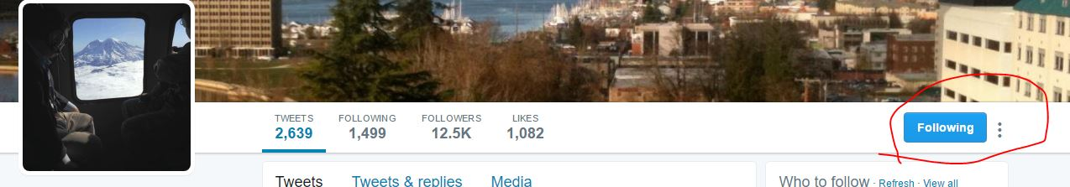
4. Below his picture there is a link where you can tweet directly to Denny. Tell him you are from District 10.

5. Scroll down his Twitter feed and like (heart) his tweets and/or comment on them.

6. Cantwell and Murray have pages that are basically the same - just search for them and repeat what you did with Denny.
This is everything you need to start interacting with your MoCs on Twitter. You can get fancier from here if you want, but this will get you started.

