Russia Questions for Denny Heck
- What’s next for the House Permanent Select Committee on Intelligence now that Nunes has stepped aside? What’s the plan for the investigation?
- With Texas Republican Mike Conaway now presiding over the House Intelligence Committee’s investigation into Russia’s meddling in the 2016 presidential election, what’s next for the Intelligence committee? What’s the plan for the investigations? Do you think the committee will be able to provide an in depth and transparent investigation?
- Is there any chance of an independence investigation?
- Do you think the House Permanent Select Committee on Intelligence has the ability to get to the bottom of the Russian scandal?
- Are you going to give Flynn immunity and under what conditions will you recommend immunity? Are you going to ask for a proffer of his knowledge first? Is your committee working with local prosecutors regarding charging Americans who may have colluded with the Russians?
- Thank you for asking that Nunes step down as chair of the Intelligence Committee as it investigates the Russian interference in our election.

Budget Questions for Denny Heck
- Which projects do you think are worth fighting for under the new budget?
- How can we obtain funding for addressing climate change under the new administration?

Other Questions for Denny Heck: (perhaps for the private April 19th meeting)
- Government shutdown and debt limit
  - Do you think we can avoid a government shutdown and get a clean spending bill or will we have to fight over unacceptable poison-pill riders in the bill?
  - Do we need to worry about government bond defaults? Trump has said that he thinks he can negotiate federal debt.
- Education
  - What steps can we take to save public schools and stop the movement towards education vouchers?
- Immigration
  - What needs to be done to stop the inhumane treatment of immigrants by ICE?
- Healthcare
  - What do you know about the most recent House Republicans healthcare talks?
- General
  - What are the building blocks or steps needed to fix the mess we are in regarding corruption and incompetence in the Trump administration?
  - How can we help you take back the House in 2018?
  - What can we do about the Justice Department’s apparent attempts to undo the reform agreements with troubled police forces nationwide?

Questions for Senators
- Thank you for using the filibuster to try and block the nomination of Judge Gorsuch.
- What does the Senate Intelligence Committee have to do with the Russian investigation?
- Do you think the Senate intelligence Committee have the ability to get to the bottom of the Russian scandal?
- Is there any chance of an independence investigation?

IMMIGRATION / REFUGEE / TRAVEL BAN
- 10 weeks since original ban was issued – now at 70 days into 120-day declared time frame. (01.27.17)
- NBC - Trump’s Immigration Policies May Give Rise to More Fraud, Experts and Advocates Warn Many articles discuss the victimization of undocumented immigrants by those who would claim to offer protection from deportation for a large sum of money.
UPDATED FIGURES ON REFUGEE ADMISSIONS
CNS News - 2,070 Refugees Arrived in U.S. in March; 54% Drop From February

Number of refugees decreasing: Of the 2,070 refugees resettled in March, the largest contingents came from Somalia (335), Syria (282), Burma (278), Iraq (192), Democratic Republic of Congo (184), Ukraine (167) and Iran (101).
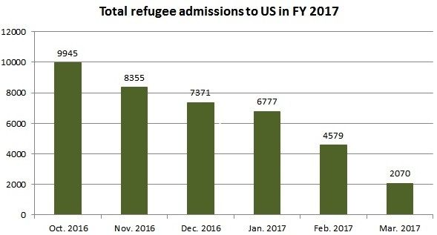

EDUCATION

https://www.insidehighered.com/quicktakes/2017/04/05/pell-eligibility-restored-some-whose-colleges-shut

The following is taken from the article:

“Democratic senators, led by Washington Senator Patty Murray, have pushed the department since last fall to grant students who attended those institutions the ability to get additional Pell funding so they could attend another university. After previously insisting that federal law did not give the department authority to restore Pell eligibility, the department in October said it would do so after all, citing a provision of the Higher Education Act identified by Murray.
In an update posted to the website of the Office of Federal Student Aid Monday, the department said it will begin to identify students who received a Pell Grant to attend a closed school and who were not reported in the National Student Loan Data System as having graduated. The department will adjust those students' lifetime Pell eligibility to remove the portion awarded to attend a closed school, the update said.”
___________________
While not directed toward the school system, I thought it was relevant to note.
H.R. 2028: To authorize the Secretary of Health and Human Services, acting through the Administration for Children & Families, to ...
... award grants on a competitive basis to public and private entities to provide exclusively education in sexual risk avoidance (meaning avoiding all sexual risk by voluntarily refraining from nonmarital sexual activity).
Date: Apr 6, 2017
Sponsor: Rep. Randy Hultgren [R-IL14]
This bill was referred to the House Committee on Energy and Commerce which will consider it before sending it to the House floor for consideration.

